**- transistor use (saturation mode) P-mos/N-mos**

**- infrared transmission – how it is used and types of it, type we used and why**

**- microcontroller - type, information, used info, translation of used commands**

**- transmission distance calculations – our calculations, tested transmission distances**

**- provide data sheets in the appendix**

**-**

**Design Documentation**

The circuit design for this project is divided into two ends, transmission end and the receiving end. The basic operation of the two designs is the following:

* Transmission End:

This design will receive the signal from the bike, stop, right, or left. The signal will be recognized and processed in the microcontroller. Next it will be sent via the IR transmitter.

* Receiving End:

This design will receive the signal being sent from the IR transmitter via the IR receiver. The recognized signal will be processed in the microcontroller to determine the required output signal, right, left, brake, right-brake, left-brake. According to what signal has been processed, the microcontroller will send the desired output to the display section to turn the LEDS accordingly.

The Design of the Transmission End:

Since the bike signal is 12V-DC, and the microcontroller device’s maximum operation voltage is 5V, the DC-to-DC converter needs to be included in the design. Figure 1 shows the design of the DC-to-DC converter circuit design. This design is taken from the device datasheet, and slightly been modified to meet the design needs. The basic functionality of this circuit design is taking the 12V-DC power signal from the bike and converting it to 5V-DC being denoted as VCC.

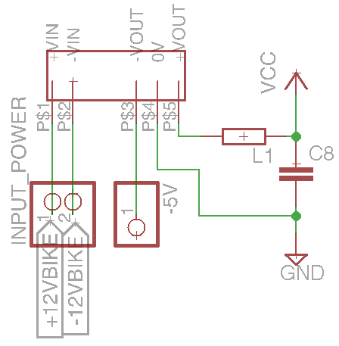

*Figure 1: DC-to-DC converter circuit design*

Figure 2 shows the design circuitry of the digital switch using P-channel MOSFET. The transmission end schematic will include three of the same circuitry, which each will connect between the microcontroller device, which in our design is the ATMEGA, and the signal connection wire from the bike, right, left, and stop. In this circuitry the bike signal’s connection wire will be connected to this circuit via the pin header named SIGNAL. The bike signal is 12V-DC. The P-Channel MOSFET has 3 inputs, Gate, Source, and Drain. Figure 2 shows these inputs of the P-Channel MOSFET, denoted as G, S, and D. The capacitor on the gate is pulled to ground to clean the currents left when the signal is from the bike is off. The pull down resistor connected to the gate will pull down the floating noise in the gate terminal. This pull down resistor is important to keep the logic of the switch as desired with noises that could terminate the functionality of the switch. The functionality of this circuit is basically a level shifting. When no signal is applied on the gate the switch is open and no signal passes to the microcontroller, the drain terminal. However, when the 12V-DC signal is applied to the gate terminal the switch is closed, and the 5V from the source terminal will pass to the drain terminal, and the microcontroller.

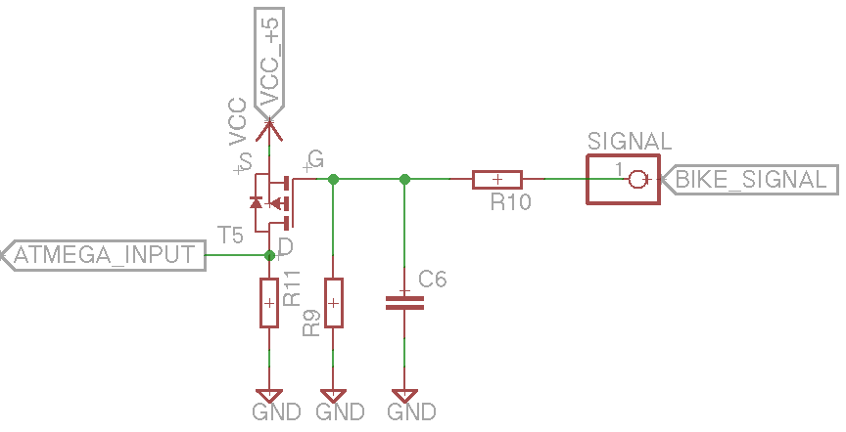

*Figure 2: The design circuitry of the digital switch using P-Channel MOSFET*

Figure 3 shows the design circuit of the IR transmitter. The P-channel MOSFET is used to amplify the current coming from the microcontroller output, ATMEGA_OUTPUT. When no signal is sent the pull-down resistor, R15 in figure 3, will pull down the floating noise in the connection wire in the gate terminal. When the signal is sent the transistor will amplify the current to the desired value to make the IR transmitter serve at its maximum operation. Since the IR transmitter and the IR receiver need to be aligned, the IR transmitter will be separated from the board and will be connected to the circuit using wires connected to pin header, JP5, and JP2.

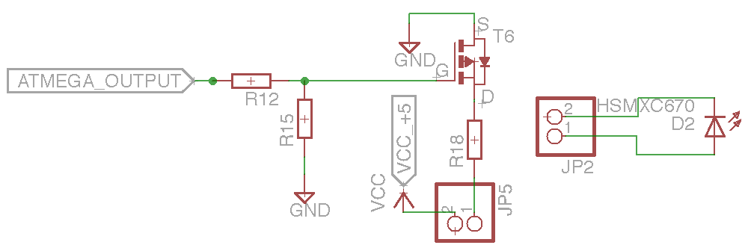

*Figure 3: The design circuitry of the IR transmitter*

Thus, figure 4 shows the final schematic of the transmission end circuit design.

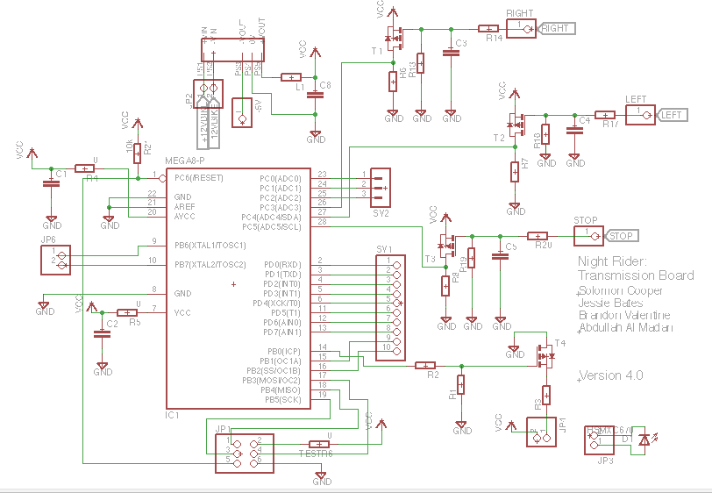

*Figure 4: The circuit design of the transmission end*

The design of the receiving end: